|  |  |  |  |
| --- | --- | --- | --- |
| **Equipment Description(s): Optotrak Certus Motion Capturing System & 6DOF Motion Simulator** | | **Equipment Number(s): MR044, MR047** | |
| **APPROVALS** | | | |
| **NAME / TITLE** | **SIGNATURE** | | **DATE** |
| Kelly Baker / GLP Program Management, Senior VP of Regulatory & Clinical Affairs |  | |  |
| Brandon Bucklen / Director of Musculoskeletal Research |  | |  |

1. **Purpose:**
   1. The following document outlines how to use “6DOF Load vs. Displacement Analyzer” to analyze hysteresis curves from spine biomechanics testing.
2. **Responsibility** 
   1. The overall responsibility for implementing this procedure is with the Director of Musculoskeletal Research.
   2. It will be the responsibility of a MERC GLP research supervisor or a designee to generate any necessary procedures, maintain, update, and revise this SOP as necessary.
   3. Research personnel perform this SOP.
      1. Read all pop-up messages CAREFULLY. It is very easy to gloss over these instructions and end up with an error. These redundancies are built in to deal with problems caused by noisy data and human error during data collection and are very thorough, albeit, sometimes annoying.
3. **Abbreviations** 
   1. ROM = Range of Motion
   2. NZ = Neutral Zone
   3. NZS = Neutral Zone Stiffness
   4. NZB = Neutral Zone Boundary
   5. EZ = Elastic Zone
   6. EZS = Elastic Zone Stiffness
4. **Reference Documents** 
   1. Wilke HJ, Wenger K, Claes L. Testing criteria for spinal implants: recommendations for the standardization of in vitro stability testing of spinal implants. Eur Spine J. 1998;7(2):148-154. doi:10.1007/s005860050045
   2. Wilke HJ, Herkommer A, Werner K, Liebsch C. In vitro analysis of the segmental flexibility of the thoracic spine. PLoS One. 2017;12(5):e0177823. Published 2017 May 16. doi:10.1371/journal.pone.0177823
5. **Operating Instructions** 
   1. Go to MATLAB and Download MATLAB Runtime R2022a (9.12).
      1. <https://www.mathworks.com/products/compiler/matlab-runtime.html>
      2. The version must be 9.12, otherwise the application cannot run.
      3. Follow the instillation instructions before running the application.

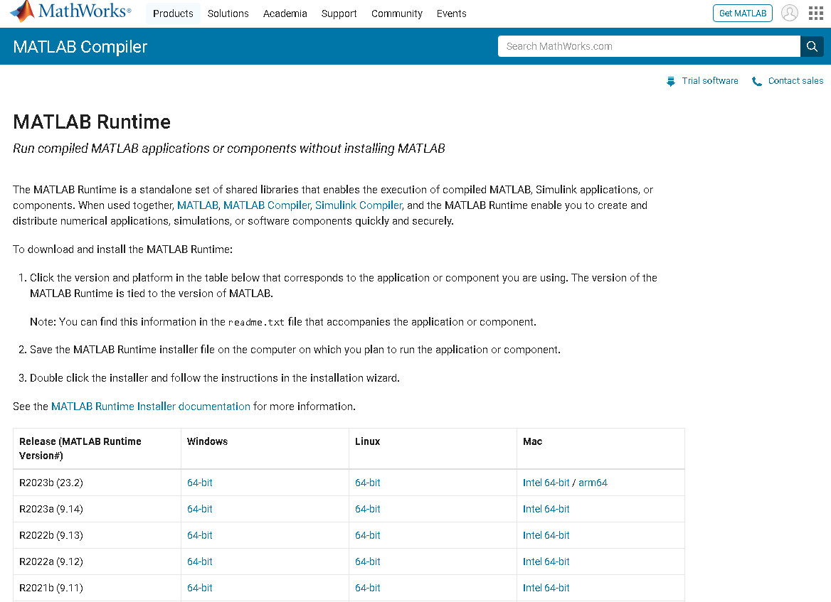

* 1. Use the following pathway to access the application: \\SW10FIL01\Research\Research Operations\Biomechanical\Software\LoadvsDisp Analysis Tools\Version 2.4\Load_vs_Displacement_Analyzer\for_testing
  2. Double-click the application “Load_vs_Displacement_Analyzer.exe”

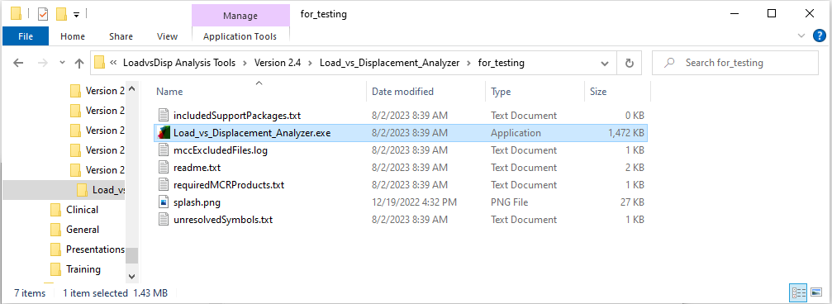

* 1. OR use the following link to run the MATLAB script:

\\SW10FIL01\Research\Research Operations\Biomechanical\Software\LoadvsDisp Analysis Tools\Version 2.4

5.3.1 Note: Be sure that the ***Statistics and Machine Learning*** toolbox and the ***Signal*** ***Processing*** toolbox are installed. If they are not, download a free trial using the add-ons button in the Home tab.

* 1. Once the application is running, the following screen will appear. This will not appear in the MATLAB script.

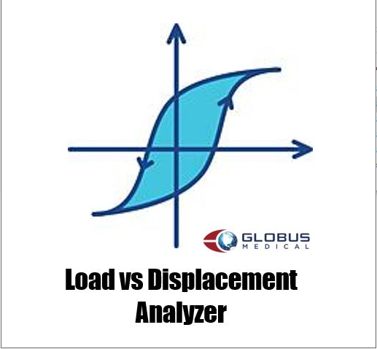

* 1. For the following steps, you will need to move the Load data and OptoTrak data to a folder on your desktop to avoid a long filepath.
     + 1. The code will not run if the file path to the data is too long so it may be advantageous to move all the organized data to your desktop and then begin the analysis.
       2. Load Data = “Motor Data”
       3. OptoTrak Data = “ROM Data”
  2. 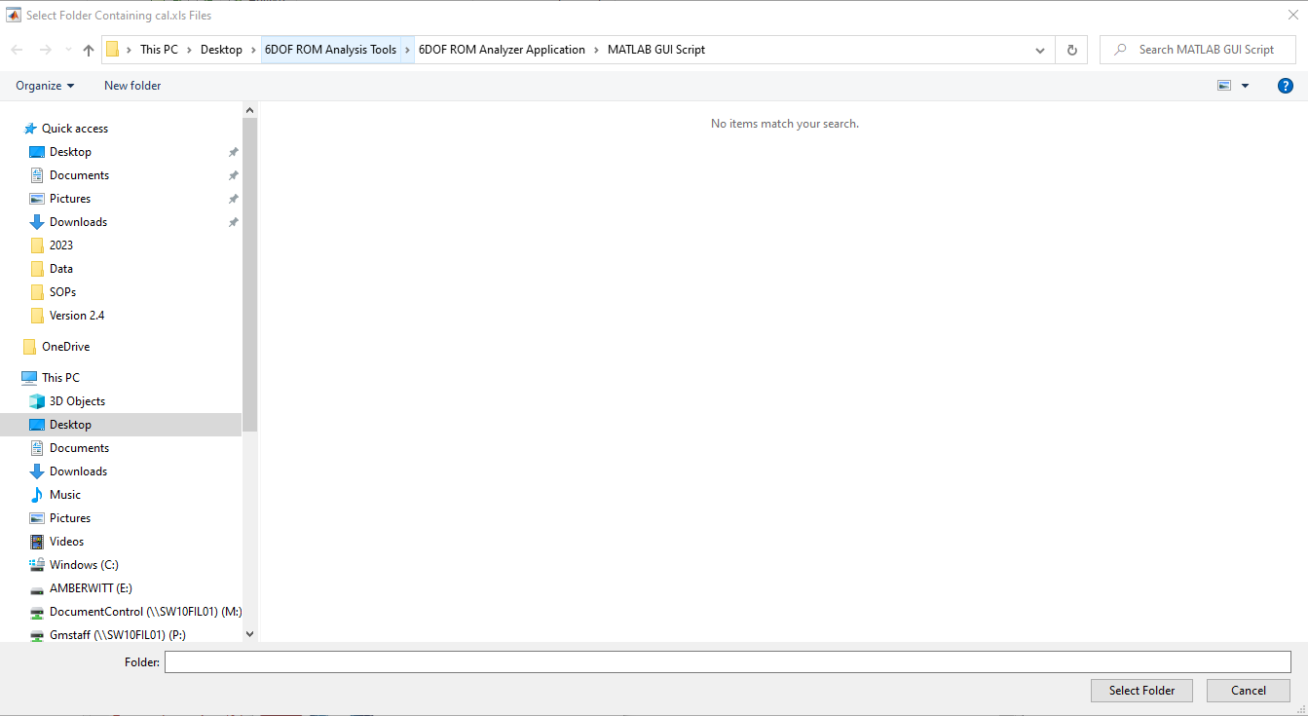The following screen will appear and prompt you to select the folder containing the data you wish to analyze.
  3. In the file address, enter the path to the Load data you wish to analyze.
     1. 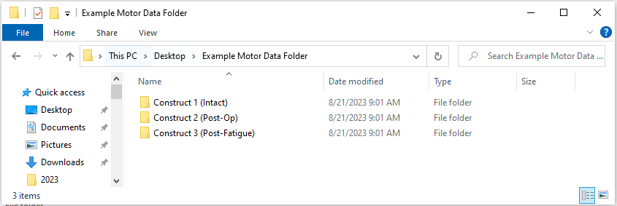For the purpose of this document. The following image is an example of the folder which the file path should lead to.
  4. Select the construct you are looking to analyze.
     1. For the purpose of this document, we will analyze “Construct 1 (Intact)”
  5. The folder you selected must contain just the excel books (.xlsx files) you are looking to analyze.
     1. The books will not be visible when you are in the folder.
  6. Click once on “Select Folder”.

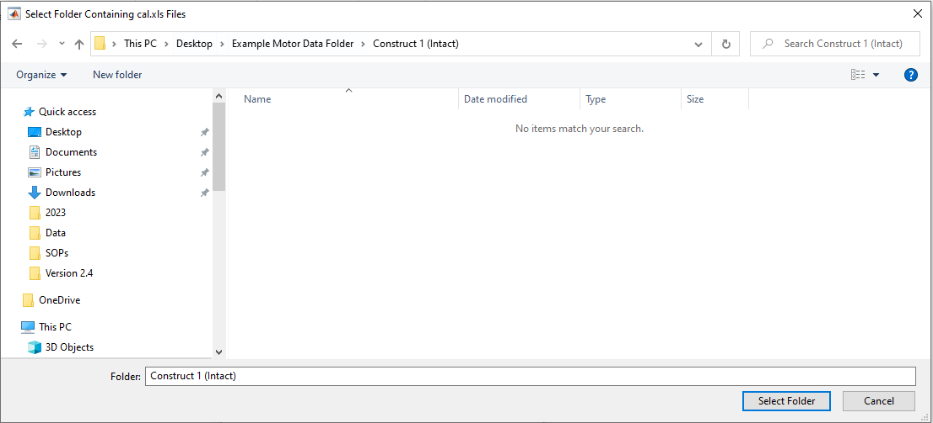

* 1. The following figure will pop up on the screen, prompting you to label the data you are analyzing.
  2. Fill in the specimen number and construct with any additional information you need to identify the specimen/construct data.

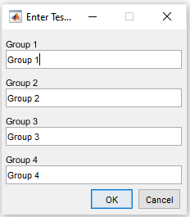

* + 1. Fill in all the lines you wish to analyze (ex. Groups 1-4). If you only want to analyze one group, just fill in that line. This is typically best practice when analyzing data that might be messy as you can better determine which sample, if any, has noisy data that is preventing the application from working properly.
    2. Click “OK” once done.
  1. The following figure will pop up on the screen, prompting you to select the books (.xlsx) you’d like to analyze.
     1. Select the books, which also correspond to which cal file, you’d like to analyze. This is particularly useful when you want to analyze individual FE, LB, and AR of a particular group. Or press “Select all” to run through FE, LB, and AR for all groups in the selected folders.

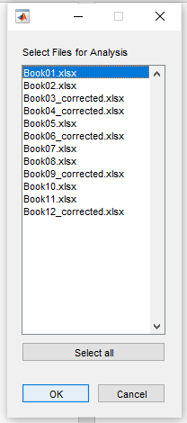

* + 1. Press “OK” when you’re ready or press “Cancel” or close this pop-up to end the application.
  1. The following figure will pop up indicating the progress of the application.

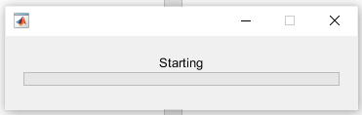

* 1. The following figures will pop up. The first is a two-part plot where the top depicts the hysteresis curve of the last cycle of the selected file (x-axis: Load, y-axis: Relative Angle) and the bottom depicts the **Relative Angle vs. time** and the **Load vs. time** data for the entire duration of the ROM test. The bottom plot also depicts the **Relative Angle** and **Load** data for the 3rd cycle (last cycle). This is what is used to generate the hysteresis plot above and will be used in this analysis.

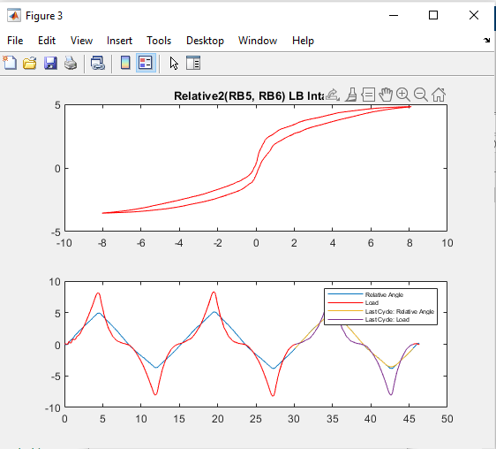

* 1. The next pop-up message will ask the user to use the tools to the top right of each plot to inspect the hysteresis curve AND the bottom plots.

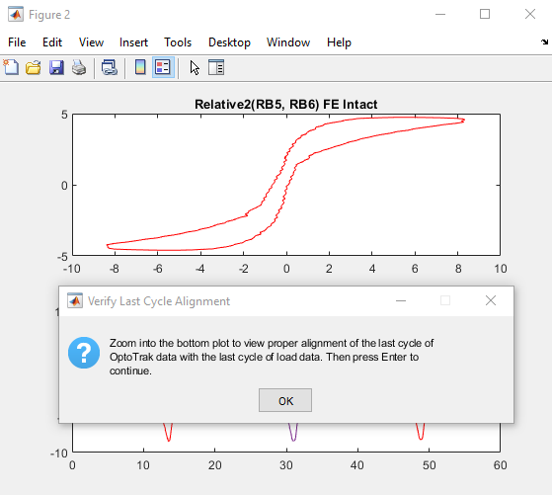

* 1. Here, the user is trying to determine if the application successfully identified the last cycle of **Relative Angle** and **Load** and generated the resulting hysteresis curve. In the figure above, the last cycle was successfully identified as shown by the last cycle of **Relative Angle** and **Load** starting and stopping on the 3rd cycle and the hysteresis curve showing the expected S-curve.
     1. Note that this S-curve can look a bit ‘wonky’ in certain conditions.
     2. Examples include fusion, instability, thoracic levels (especially with intact rib cage), or the OptoTrak system recording too far ahead or behind the data from the 6DOF load cell. This is because the OptoTrak system collects data at a higher frequency (~100 Hz) than the 6DOF load cell (~10 Hz) and these systems are not synched which means that resolution of the OptoTrak data needs to be decreased by a factor of 10 before the peaks and valleys of both data sources need to be lined up.
     3. If the application fails to run for any sample, it is best to go back to the Optotrack data and see if there is substantial lag OR extra peaks/valleys before or after the motion starts (shown below).

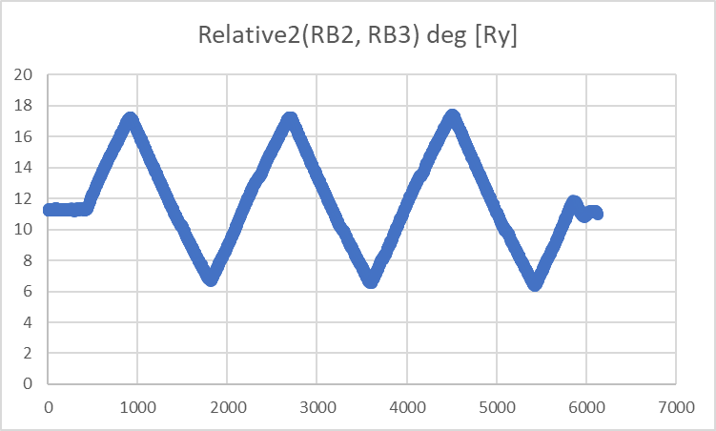

Problematic OptoTrak Data: There is too much lag at the beginning of the OptoTrak data indicating that the OptoTrak record button was pressed too far ahead of the START button on the 6DOF controller. Additionally, the end of the last cycle oscillates slightly (extra peaks and valleys) before stabilizing at its starting point (x-axis). These aspects confuse the application when it tries to identify the last cycle of the OptoTrak data.

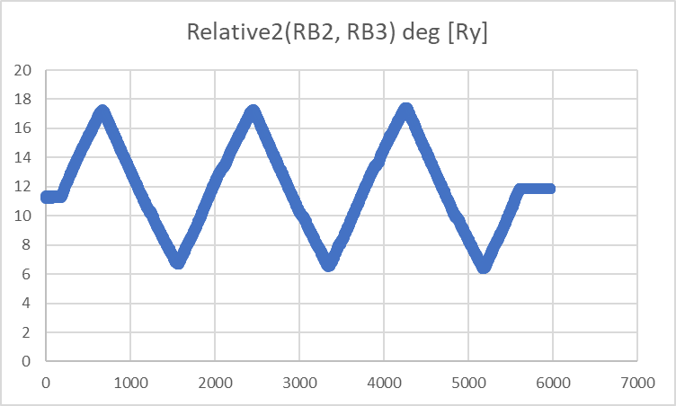

Corrected OptoTrak Data: Much, but not all, of the initial lag was removed and all data after the point where the relative angle returns to its starting point (x-axis) is removed and replaced with a straight line of this value. This makes it much easier for the application to identify the last cycle.

**IMPORTANT NOTES**: When correcting OptoTrak data, always make sure:

1. The time column always starts at 0 and proceeds in increments of 0.01.
2. All columns should be the same length and have no missing values.
3. No extra columns or graphs are present.
   * 1. While some hysteresis curves look abnormal, the user should rely on the last cycle of the **Relative Angle** and **Load** overlay on the bottom plot to determine if the application properly identified the last cycle.
   1. Below is an example of a “wonky” hysteresis curve.

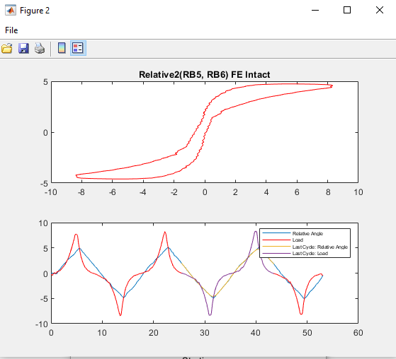

Problematic OptoTrak Data: The application failed to properly select the last cycle of OptoTrak and Load data as shown by the abnormally flat elastic zone (tail ends) of the hysteresis curve. As shown in the bottom plot, the application selected the end of the second cycle and the beginning of the third cycle as the data to create the hysteresis curve. This is likely due to the misalignment between the peaks of the OptoTrak data being out-of-phase with the peaks of the Load data. As shown in the plot in section **5.14**.

* 1. Following the instructions in the previous popup message, once the validity of the hysteresis curve has been determined, press the “Enter” key and the following popup will appear asking whether or not the user would like to manually select the last cycle of Load and OptoTrak data.
     1. Press “YES” if there is visual confirmation that the application failed to correctly select the last cycle of data.

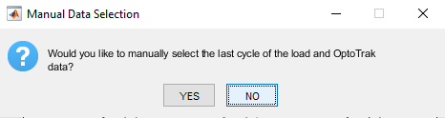

* 1. A new figure will pop up with the Relative Angle vs. Time plot. Follow the instructions in the Title, press “Enter” and right-click and drag the cursor over where the last cycle starts (x-axis), as shown by the **dashed box** below.
     1. Note: The algorithm will select the point closest to the x-axis (i.e. the natural angle).

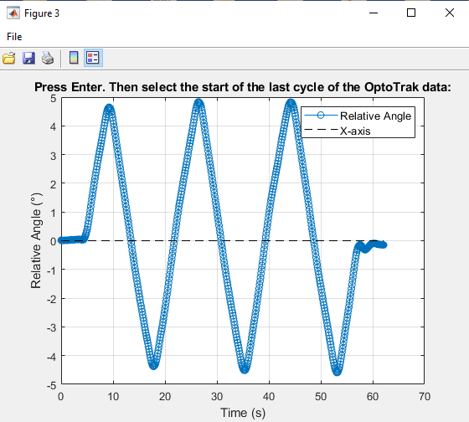

* + 1. Press “Enter” and right-click and drag the cursor over where the last cycle ends, as shown by the **dashed box** below.

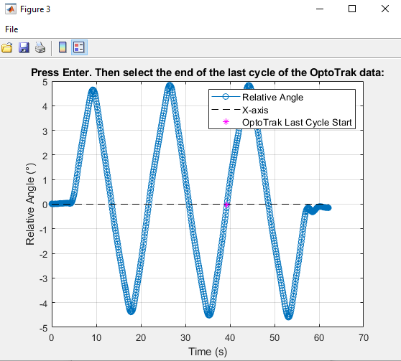

* + 1. A new figure will pop up with the Load vs. Time plot. Follow the instructions in the Title, press “Enter” and right-click and drag the cursor over where the last cycle starts (x-axis), as shown by the **dashed box** below.
    2. Note: The algorithm will select the point closest to the x-axis (i.e. zero load). Because the hysteresis curve needs the same number of OptoTrak data points as Load data points, the application will automatically select the end of the cycle based on the number of data points of selected OptoTrak data in the last cycle.

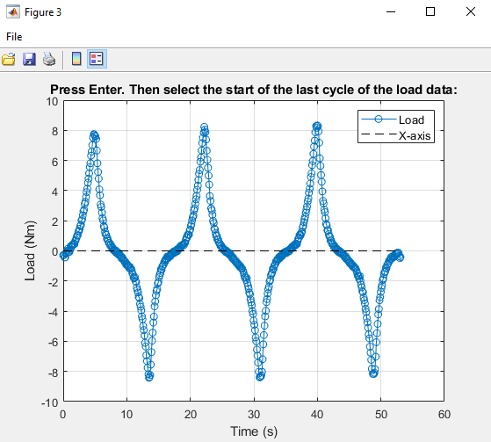

* + 1. The last cycle of the Load data will turn red and the Load vs. Time plot will close. Then the two-part plot from section **5.16** will auto-update showing the “shifted” last cycle of the **Load** relative to the **Relative Angle**. This will cause the last cycle of the **Relative Angle** to “shift” to the left. Ideally, this would cause the last cycle of the **Relative Angle** to match up with that of the **Load** and the resulting hysteresis curve to be corrected, as shown below.

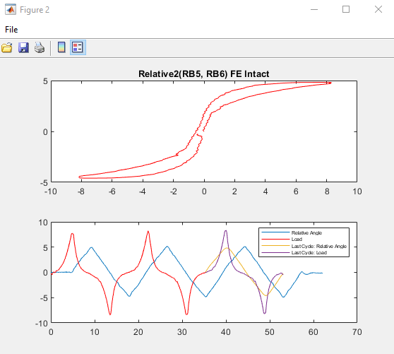

Corrected OptoTrak Data: The peaks and valleys of the corrected OptoTrack last cycle now align perfectly with those of the last cycle of Load as shown by the bottom plot. This is confirmed by the S-shape of the hysteresis curve that looks much more similar to the ideal curve as shown in section **5.16**; however, there now exists a discontinuity that may affect the analysis going forward. To correct for this, see section **5.22** below.

* 1. A new popup figure will appear asking if the user is satisfied with the correction. If the hysteresis curve is sufficient for analysis, press “YES”. Otherwise, press “NO” and the application will run through the steps outlined in section **5.21** again until a suitable hysteresis curve is generated. This can take time and is more of an art than a science. Try to adjust where you select the starting point of the 3rd cycle for the Optotrak data as this can have drift at very low ROM.

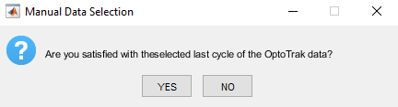

* 1. The next popup figure will ask the user whether or not they would like to manually select the NZ. This is a very important decision in the analysis.

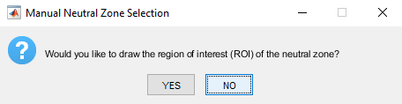

* + 1. Wilke et al. determined a lot of the metrics that are commonly used in spine biomechanics today. They created criteria for extracting information from hysteresis curves. For NZ, they assume that there are only 2 points in an ideal hysteresis curve where the curve interacts with the zero-load point (y-axis) and these are the top and bottom phases of the curve. This application detects NZ, which is a measure of spine laxity, according to the Zero Load method developed by Wilke et al which is the deflection between the phases of motion where no torque is applied to the spine (i.e. in its neutral position). See reference documents 4.1 and 4.2 for more.

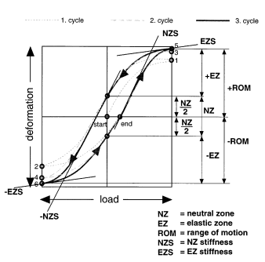

Hysteresis curve from Wilke et al describing the standardization of hysteresis curve analysis. Typical load–displacement curve (cycle 1–3) with continuously changing load with definitions of the parameters (ROM, EZ, NZ, NZS, EZS). Positive load indicates right lateral bending (+Mx), flexion (+My), or left axial rotation (+Mz) and negative load indicates left lateral bending (–Mx), or extension (–My), or right axial rotation (–Mz). See reference document 4.1 for more.

* + 1. From the application’s perspective, on the 3rd cycle, the curve starts out at the bottom intersection or negative NZ boundary (negNZB) then rises until it reaches its maximum angulation and torque before coming back down, intersecting the y-axis again at the position NZ boundary (posNZB) before it reaches its minimum angulation and torque before ending at the same point at which it started.
    2. Therefore, if there are less than or more than 2 intersections with the y-axis the application will become confused. Examples of this include discontinuities like the one shown in section **5.21.5**, noisy data that creates more than two intersections with the y-axis (zero load), and abnormal curves where the posNZB is below the negNZB that can happen due to small ROM or extreme stiffness in one direction.
    3. For these “wonky” cases, the application will attempt to analyze the hysteresis curves, but the user must visually inspect the resulting curves to make sure that the values are extracted correctly. If the hysteresis curve does not look as the user would expect, the user can re-run the application and manually select the NZ by determining the posNBZ and negNBZ. If that is needed, press the “YES” button in the popup in section **5.23** or “NO” to have the application attempt to extract it and move on to section **5.25**.
  1. A new figure will pop up with the plotted data points for the hysteresis curve of the last cycle.

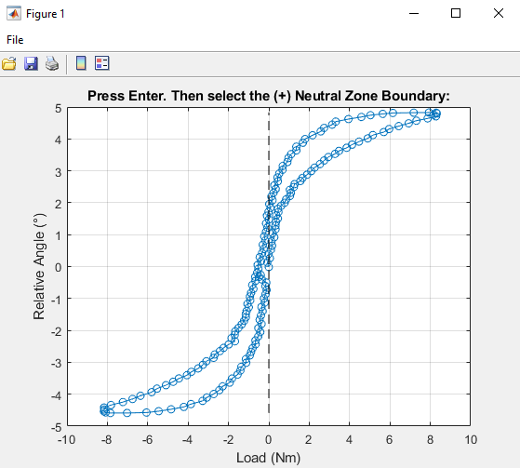

* + 1. Zoom in towards the y-axis (dashed line) until you can see the difference between the two phases of the hysteresis curve. Follow the instructions in the Title, press “Enter” and right-click and drag the cursor over where the posNZB should be, as shown by the **dashed box** below.
    2. The selected posNZB will be indicated by a horizontal dashed line. The Title will change giving instructions to select the negNZB. Press “Enter” and right-click and drag the cursor over where the posNZB should be, as shown by the **dashed box** below. Then the negNZB will also be indicated by a horizontal dashed line.

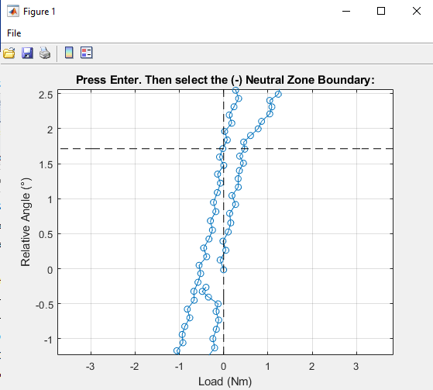

* + 1. Note: The algorithm selects the posNZB as the point on the 2nd phase of the hysteresis curve (comes after the maximum angulation is reached) that is closest to zero-torque (y-axis) and the negNZB as the starting point of the last cycle. This is typically because the beginning and end of the last cycle should in theory be the same position. When in the manual NZ selection mode, the algorithm switches to only finding the point in the cursor-drawn box that is closest to the y-axis for the posNZB and negNZB. If the user draws a box that is too far from the y-axis, the application will display an error message prompting them to try again. In the case of discontinuities, it is recommended that the posNZB be taken when the last cycle starts.
    2. The Title will change again prompting the user to press “Enter” and right-click and select the intersection between the NZB and the 1st phase, as shown by the **dashed box** below.

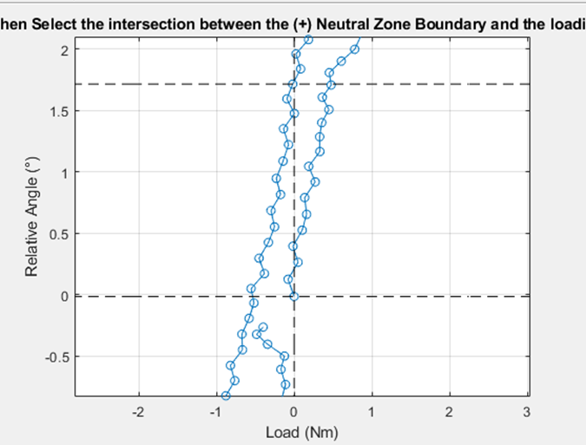

* + 1. The data points between the posNZB and negNZB (i.e. the start of the last cycle) on the 1st phase will be shown in red for visual confirmation of the loading NZ. The Title will also change prompting the user to select the intersection between the negNZB and the unloading phase, as shown by the **dashed box** below. The data points between the posNZB and negNZB on the 2nd cycle will also appear red for visual confirmation of NZ selection before the figure closes itself.

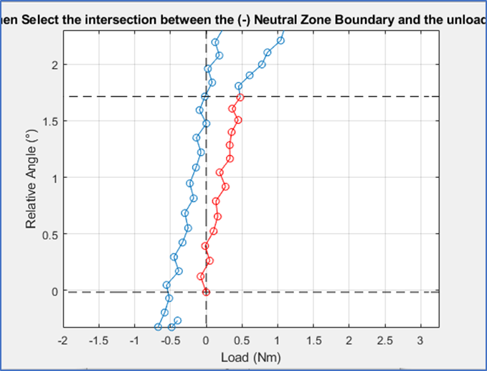

* 1. The application will now attempt to automatically extract the NZ, posNZB, negNZB, posNZ stiffness, negNZ stiffness, posEZ, negEZ, posEZ stiffness, negEZ stiffness, and area of the hysteresis curve. These will be shown on a new figure of the hysteresis curve as the **red data points**, the **top red ‘*’**, the **bottom red ‘*’**, the **right-most black line**, the **left-most black line**, the **right-most magenta datapoints**, the **left-most magenta data points**, the **top green line**,the **bottom green line**, and the yellow-highlighted region respectively, as shown below. Additionally, the application will attempt to extract ROM and the maximum and minimum angulation.

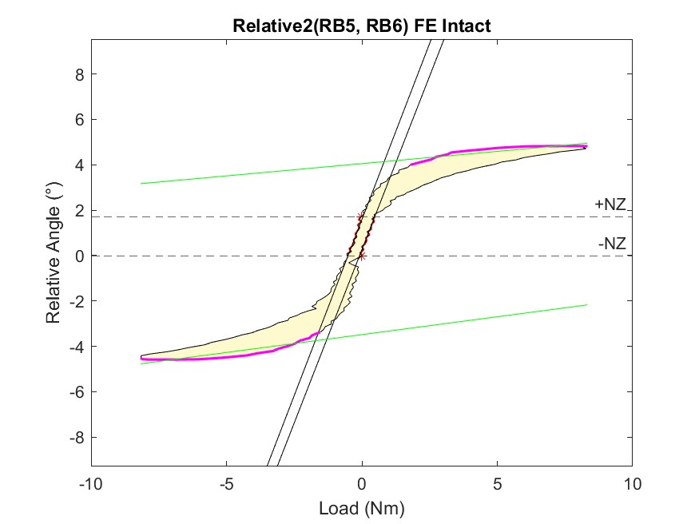

* 1. After the application has analyzed all the selected OptoTrak and Load files, a final pop-up will appear asking the user if they would like to run the script again.

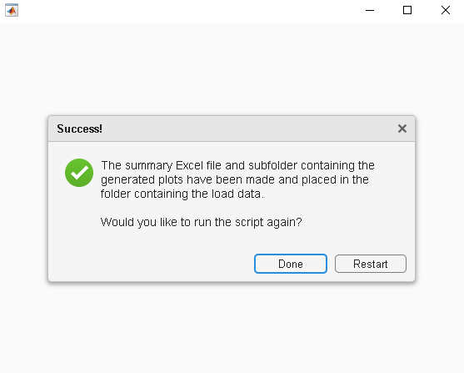

* + 1. Pressing “Done” will close the application, while pressing “Restart” will run the application again after prompting the user to select data once more. Before clicking either option the user should look through the plots saved in the “Angular Displacement VS Load Plots” subfolder as shown in section **5.28**. If the hysteresis curves are not as expected and/or the extracted features don’t make sense, the user should consider pressing “Restart” for these situations.

* 1. In the folder containing the OptoTrak data used in this analysis, there should appear a new Excel spreadsheet called “Specimen Summary – Hysteresis Curve.xls”.

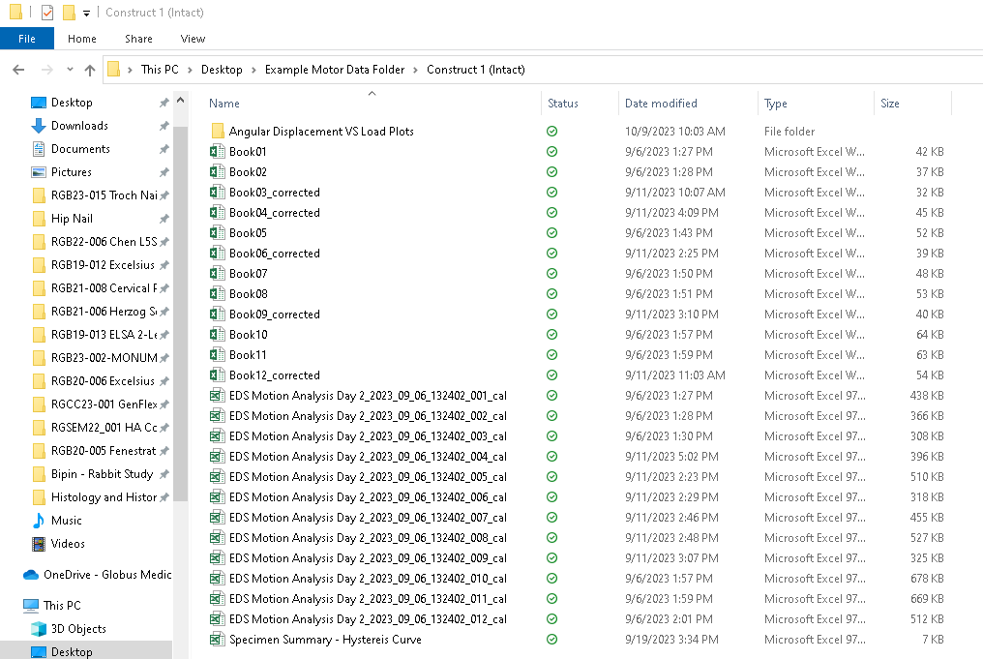

* + 1. In this spreadsheet, there will be a tab for each relative analyzed. In each tab there will be a row for every cal and Book file combination analyzed (FE, LB, or AR for every construct) with all the extracted data from the hysteresis curve outlined in section **5.25**.

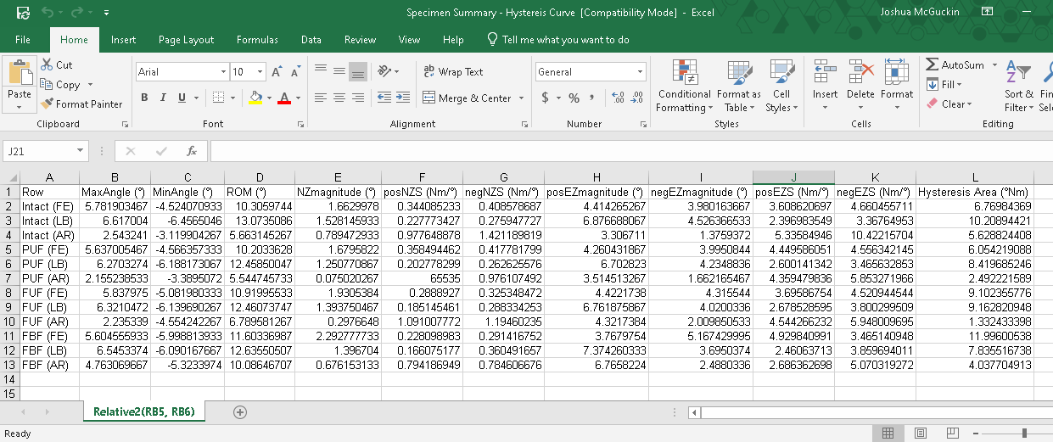

* + 1. Note. It is the responsibility of the user to verify the validity of the application’s findings based on the hysteresis curve. If the curve looks as expected, the user can usually trust the results; however, if the curve looks “wonky”, the user should consider correcting the OptoTrak data as shown in sections **5.17-5.23**. If this also fails to produce a suitable hysteresis curve, the user can try to manually extract useful information by manually plotting the hysteresis curve from the last cycle data as shown in section **5.28.2**.
  1. In the folder containing the Load data used in this analysis, there should appear a new folder called “Angular Displacement VS Load Plots”. In this folder, there will be 3 types of files for every cal and Book file combination analyzed. These will include JPEGs, MATLAB Figs, and Excel spreadsheets.

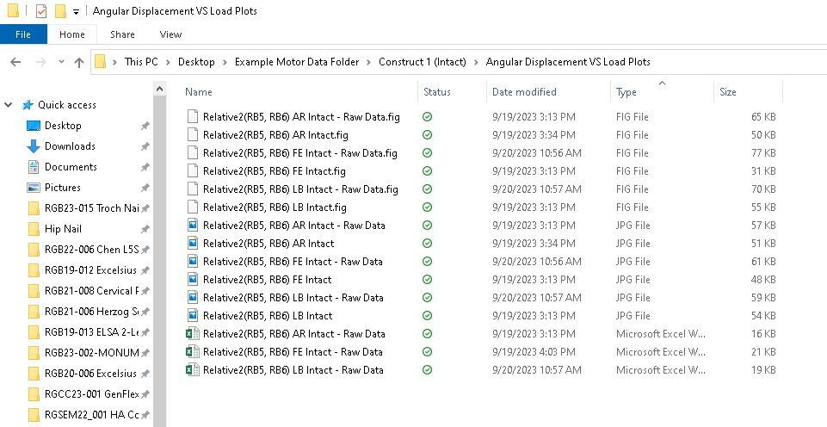

* + 1. Of the JPEGs and MATLAB Fig files, all filenames with “Raw Data” in them are plots showing the hysteresis curves and raw Relative Angle vs. Time and Load vs. Time subplots, like those shown in section **5.16**. These are intended for the user to visually confirm that the application properly extracted the last cycle of OptoTrak and Load data. All filenames without “Raw Data” in them are the hysteresis curves with extracted features shown visually as seen in section **5.25**.
    2. The Excel spreadsheets contain two tabs. **Sheet1** will contain the Time, Load, and OptoTrak data for all 3 cycles after the application lines up the peaks of the Load vs. Time and OptoTrak vs. Time data and decreases the resolution of the OptoTrak data to make it compatible with the Load data (remember that the 6DOF load cell captures data a lower frequency than the OptoTrak cameras). **Sheet2** will contain the Time, Load, and OptoTrak data of the last cycle so that the user can use this data for analyses outside the scope of this application.

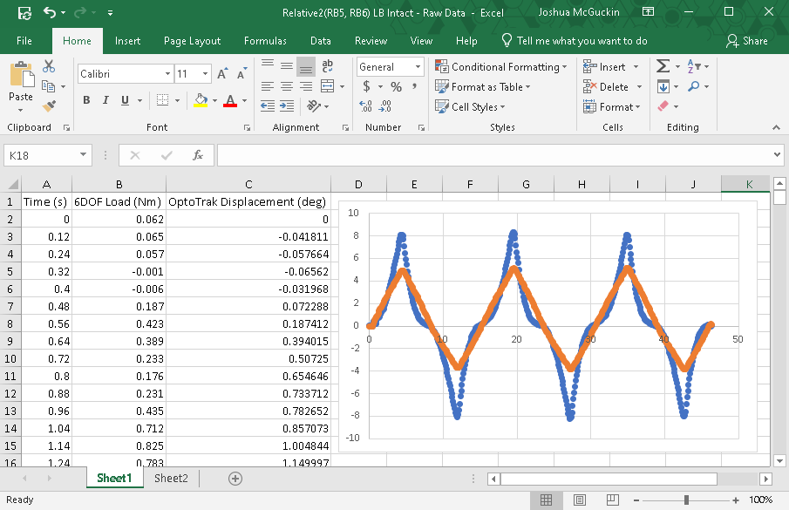

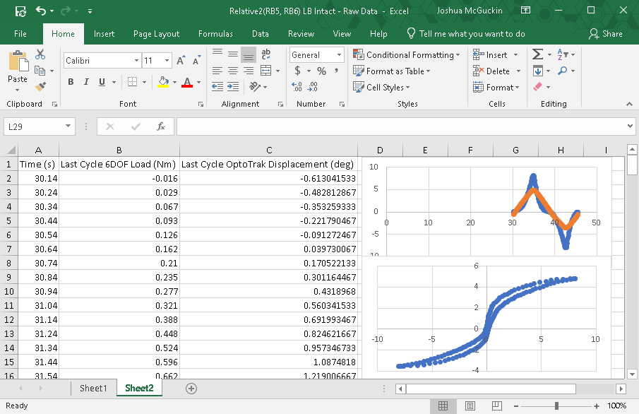

* 1. If, for whatever reason, the application encounters a fatal error that prevents it from running the analysis, the following warning message will pop up.

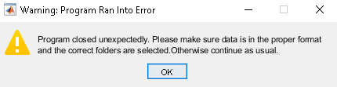

* + 1. There are a number of reasons that this may occur, but some of the most common include discontinuities in the OptoTrak data usually due to blocked rigid bodies, severely abnormal OptoTrack data where peaks cannot be determined (e.g. high drift or extremely low ROM), extra columns in the OptoTrak data that are not part of the original output (e.g. when normalizing relatives), mismatch in the number of OptoTrak and Load files, and too much lag in the OptoTrak data.

1. **Maintenance Procedures**
   1. Verification
      1. Verification of the extracted parameters in the “Specimen Summary – Hysteresis Curve” should be done on an as-needed basis. The user can compare these to those manually calculated using the output Excel spreadsheets with the last cycle OptoTrak and Load data.
   2. Validation
      1. This application makes several key assumptions in order to run properly. One of them is that the spine is in pure bending, meaning that there is universal torque applied between levels and no compression. Without this assumption, torque cannot be accurately determined between different levels and the hysteresis curves cannot be reasonably trusted.
      2. It is the responsibility of the supervisor and acting owner of the application to validate these assumptions with the current working 6DOF motion simulator setup.
   3. No other maintenance is required with the application.
      1. As more updates for MATLAB addons become available, the MATLAB script must be checked to see if the functions are still compatible with the version of MATLAB being run on the user’s machine.
   4. Updates to the code should be made in the MATLAB script and saved/named appropriately prior to any changes being made: \\SW10FIL01.gminc.local\Research\Research Operations\Biomechanical\Software\LoadvsDisp Analysis Tools

|  |  |  |  |  |
| --- | --- | --- | --- | --- |
| 1. **REVISION HISTORY** | | | | |
| **REV #** | **DCO #** | **DESCRIPTION OF CHANGE** | **AUTHOR** | **EFFECTIVE DATE** |
| 0 | MR 6.35 | Original Release | Joshua McGuckin  &  Amber Witt | 10/13/23 |
|  |  |  |  |  |
|  |  |  |  |  |